**Part : 1 Feature Extraction**

**(1) Read the image and Convert it into gray level image :**

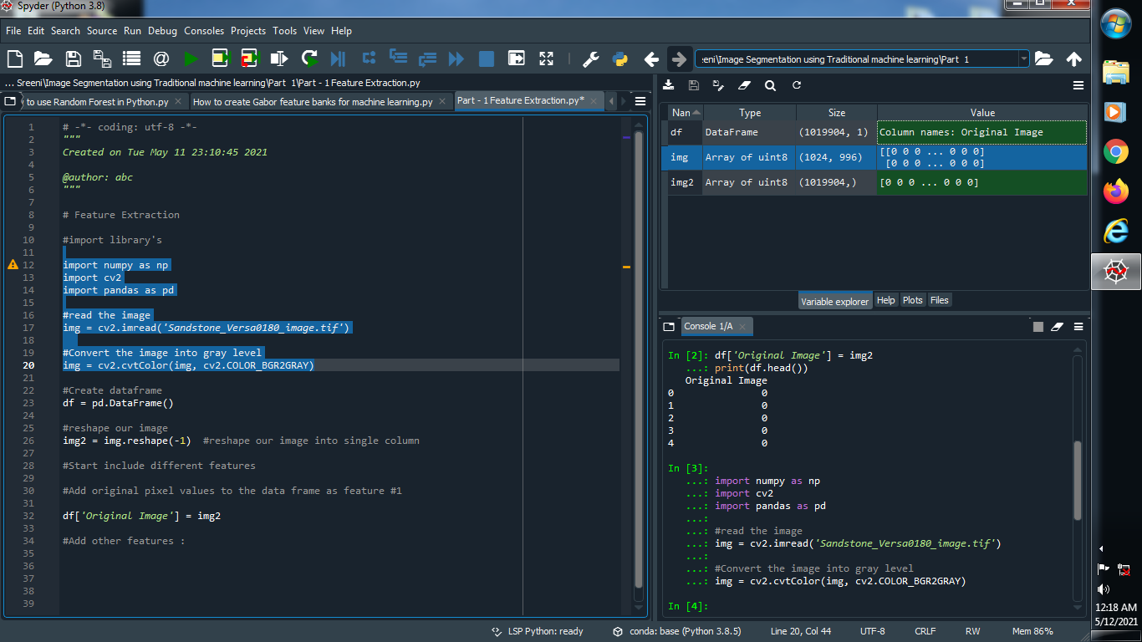

**Output :**



**(2) Reshape our image into single dimension :**

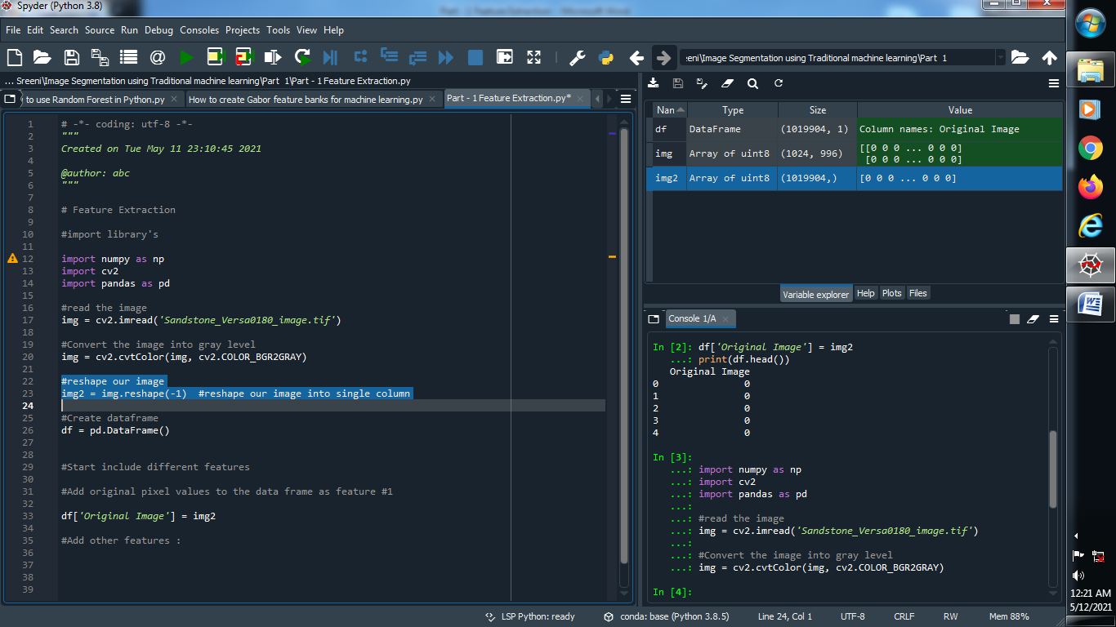

**Output :**



**(3) Create one dataframe and named it’s column name :**

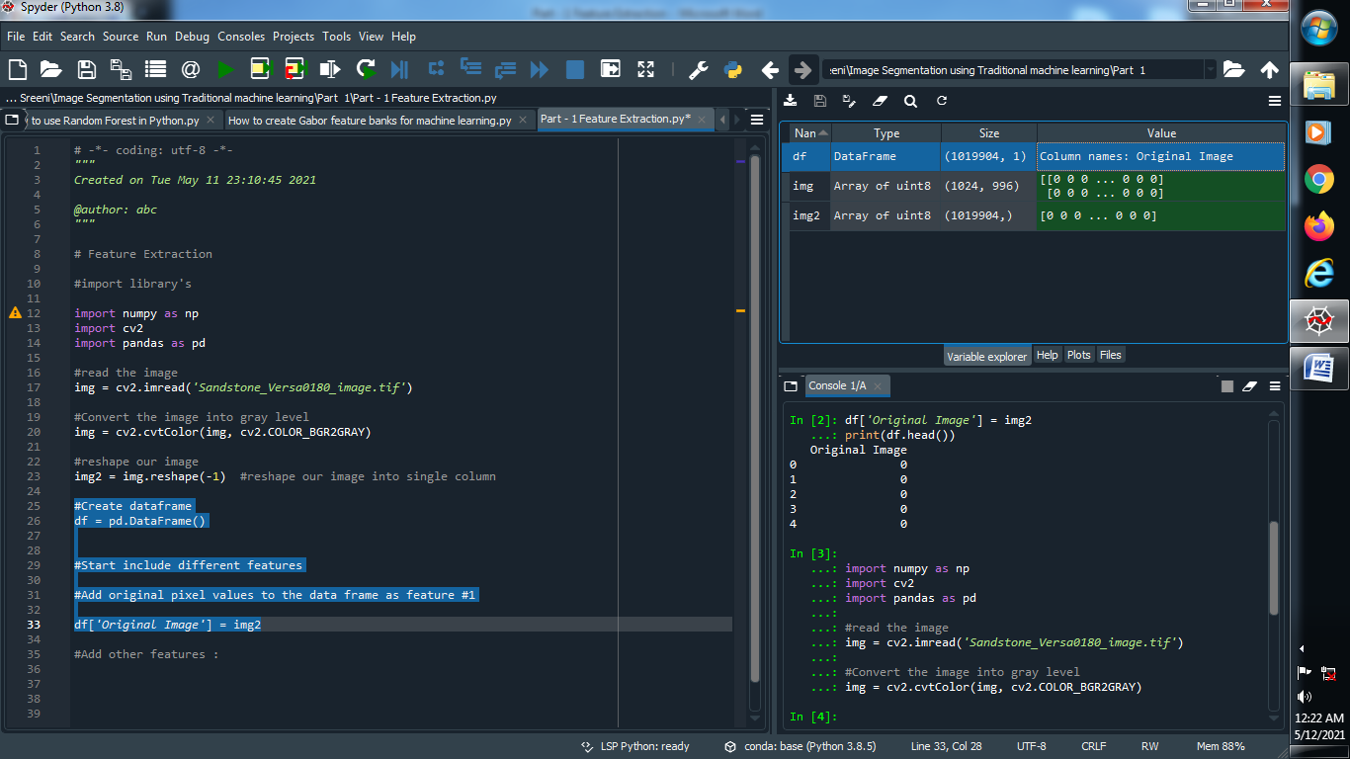

**Output :**



**(4) Add another features :**

**(I) Gabor features :**

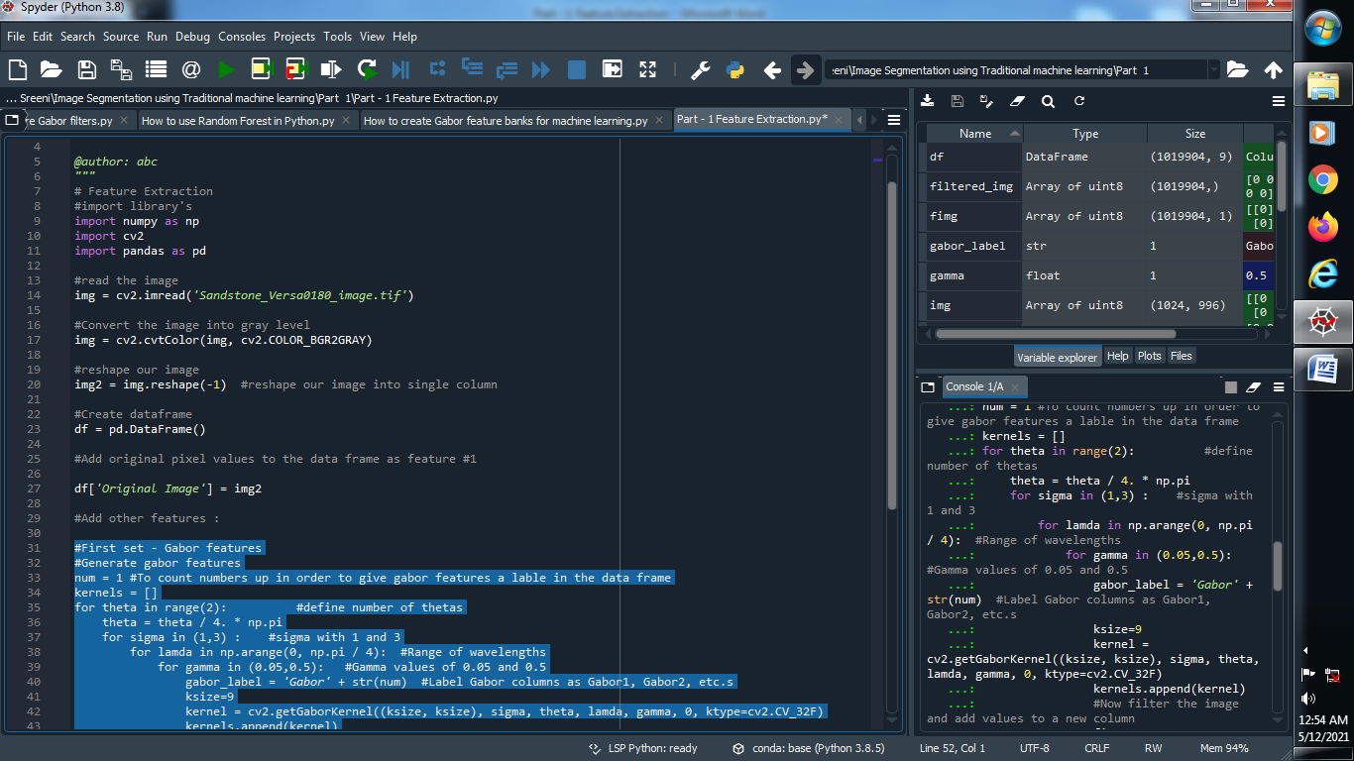

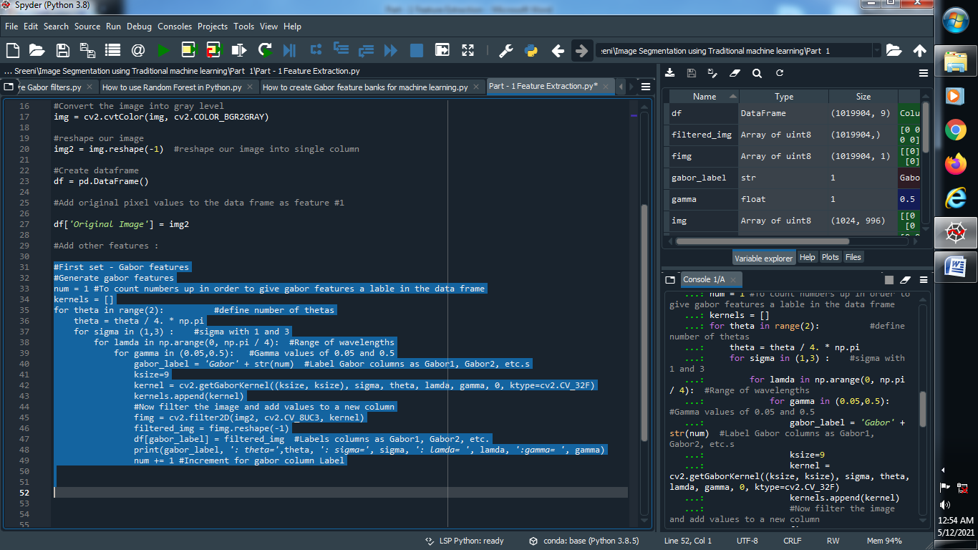

**Output :**

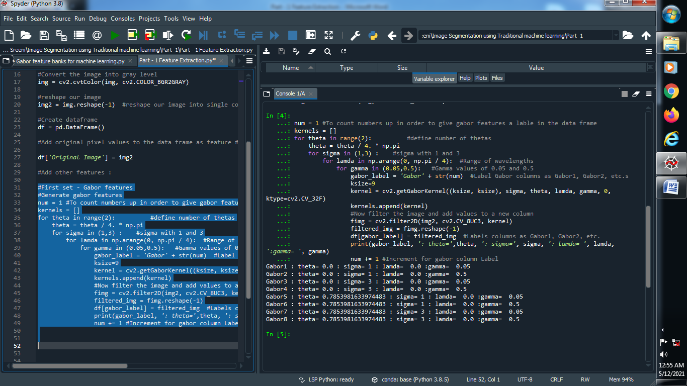

**(II) Apply Canny Edge filter :**

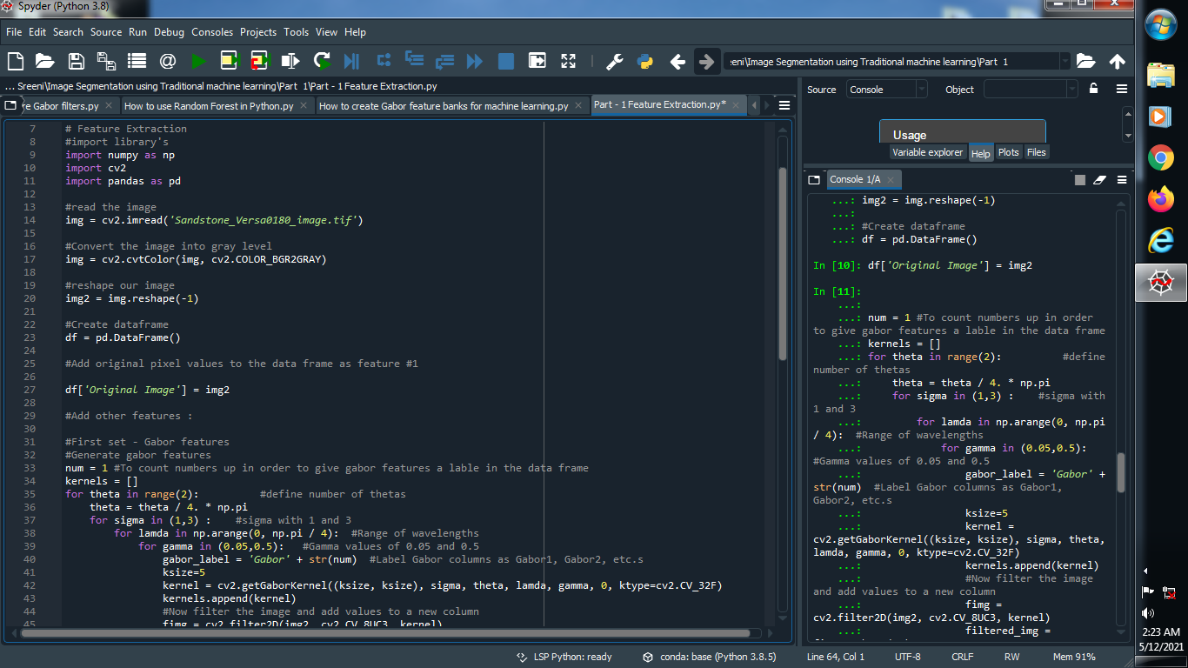

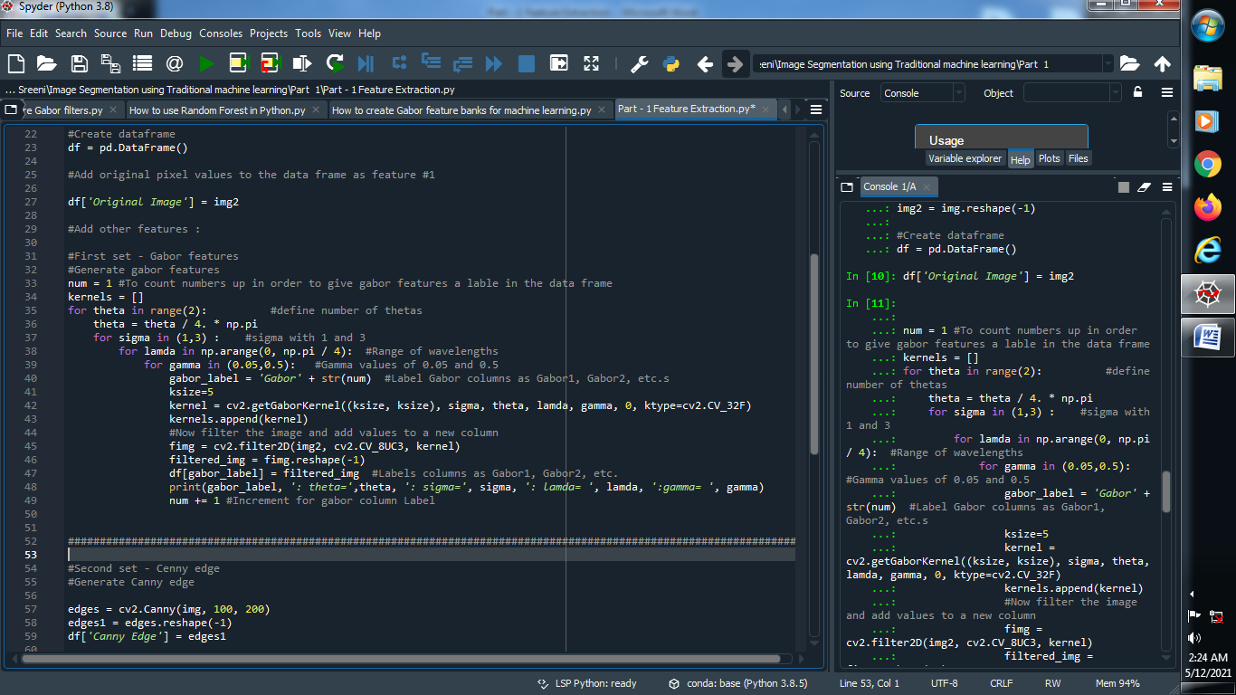

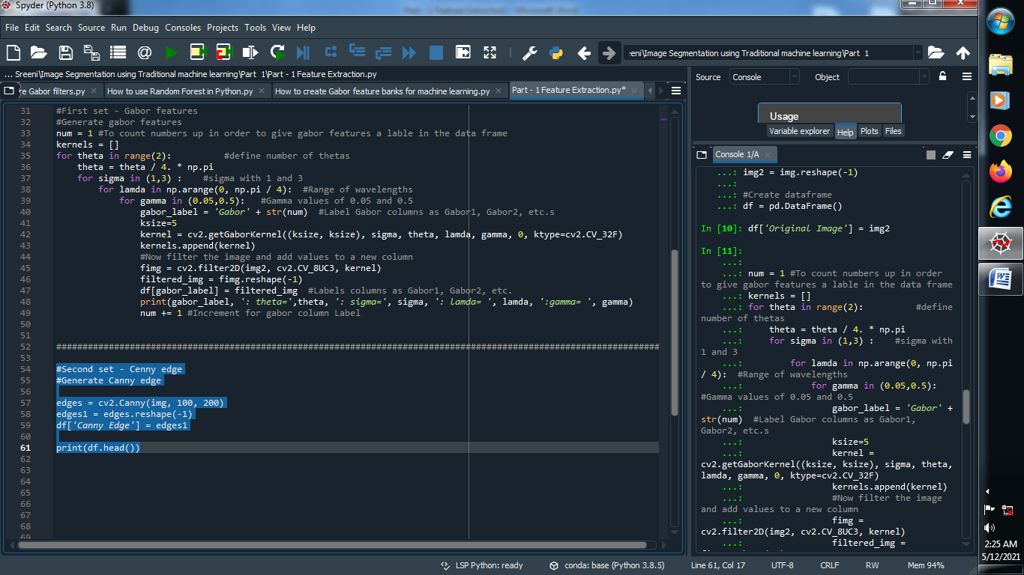

**Output :**

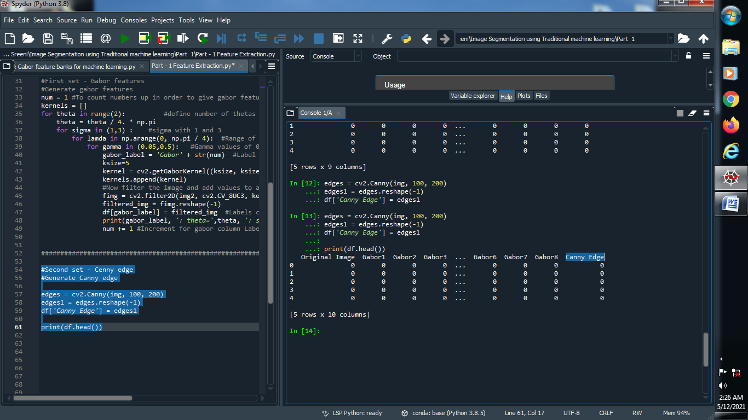

**(III) Apply Roberts, sobel, scharr, prewitt, gaussian, median filter :**





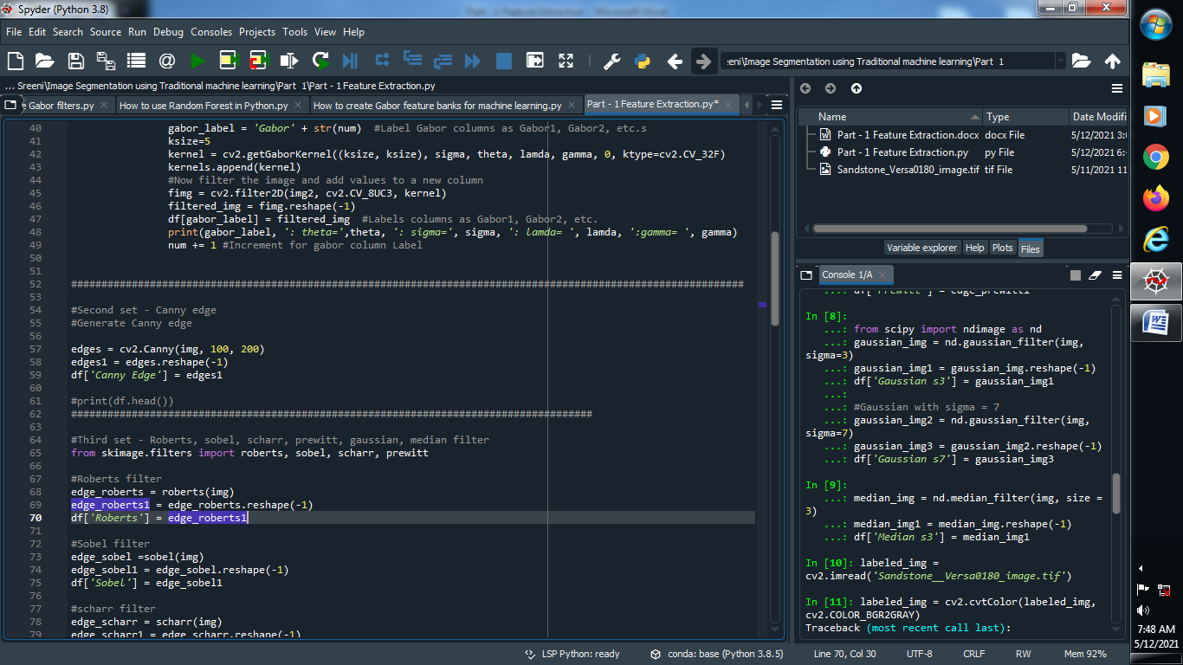

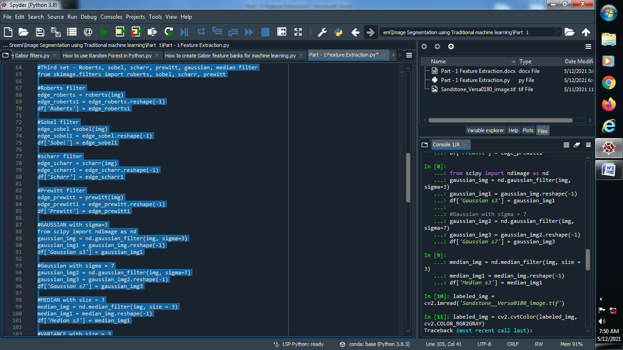

**→ Output :**

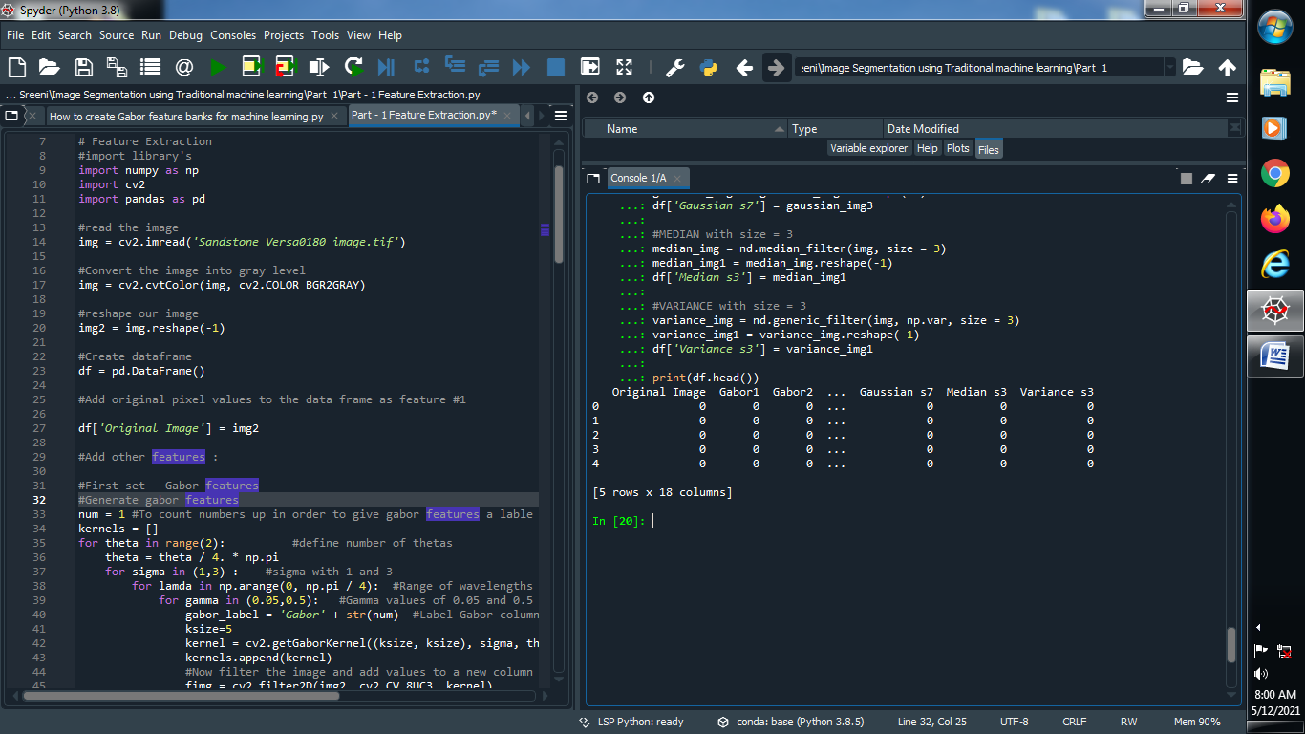

**→ Add one column that corresponds to image :**

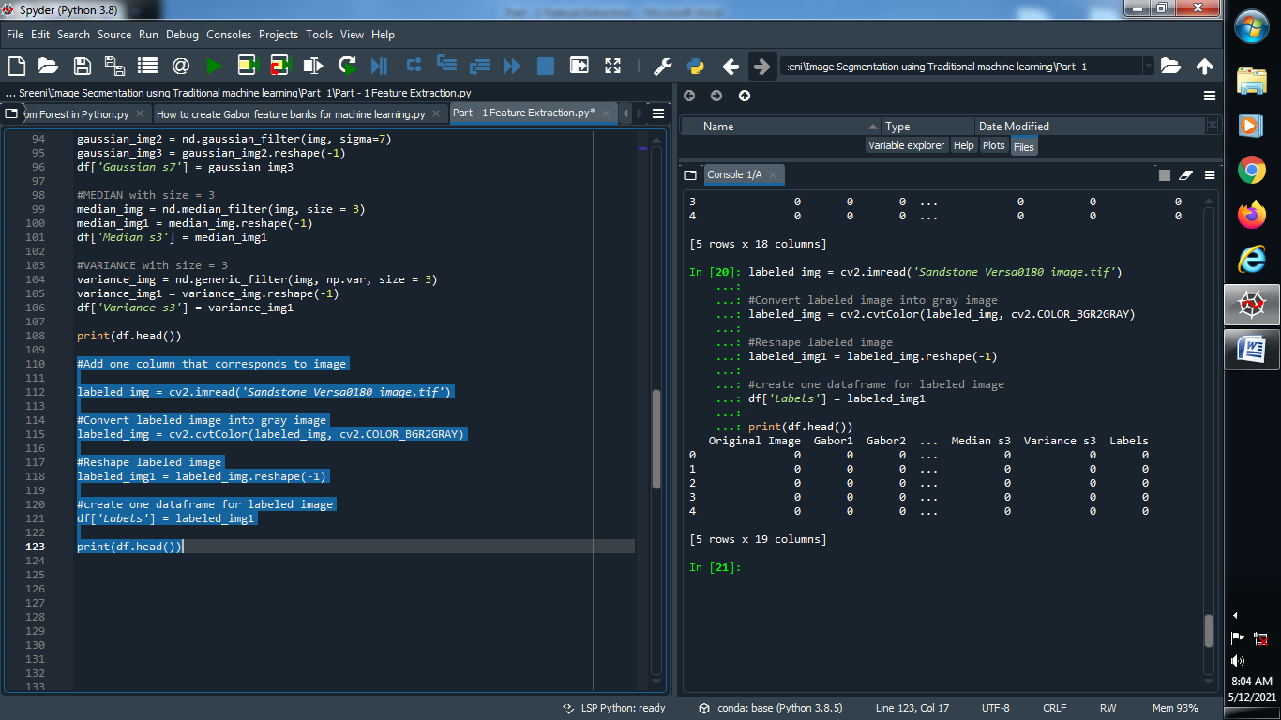

**Output :**

